American Imperialism Map

Use the maps from chapter 18 (pages 562, 555,551)

Label and color RED with COLORED PENCIL (not marker) the following areas, and draw boundaries where necessary:

Alaska Hawaii Cuba Philippines

Puerto Rico Panama China

Label and color GREEN with COLORED PENCIL the United States.

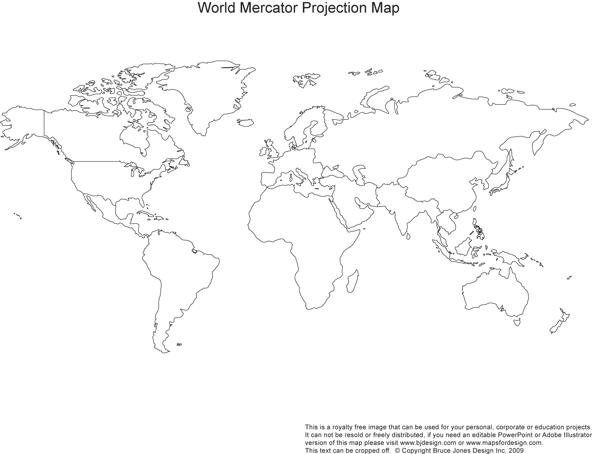Name __________________

American Imperialism Map

**Answer the following questions:**

1. Which of the areas you labeled is closest to the U.S.? Which is the farthest?

2. For each of the areas shown, speculate about the ways in which you think each area would be important to the United States. Be as specific as you can.

Alaska –

Hawaii –

Cuba –

Philippines –

China –

Panama –