Name________________________________________________

The Influenza Pandemic of 1918—hw

**Read the selection below and answer the questions.**

1. How many people died of from the Influenza Pandemic?
2. Did more people die of this influenza pandemic or from the Bubonic Plague? Why do you think so?
3. Describe how influenza would affect people who got the disease.
4. What does the rhyme that children would skip rope to tell you about the affects of the disease?
5. Why didn’t people respond to the first epidemic that struck military camps in Kansas?

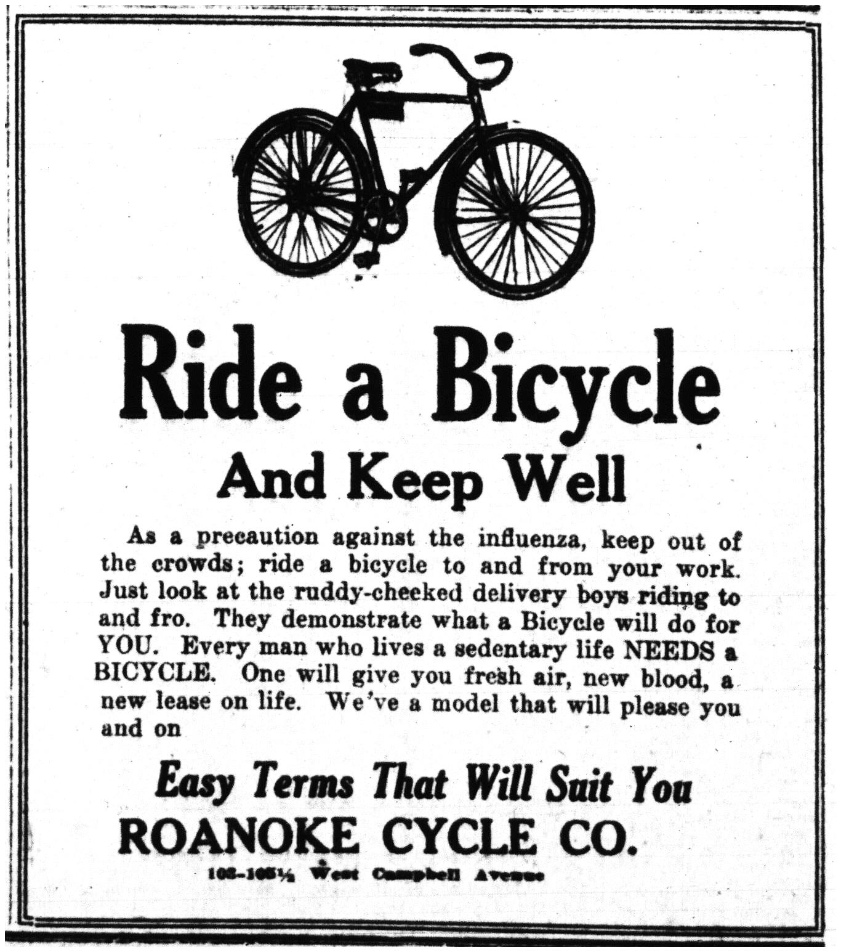

1. How did the war help the disease spread?
2. How did the pandemic affect public health ordinances?
3. Examine the advertisement to the right.

What are they trying to sell?

How are they trying to persuade the reader to buy that product?

1. How do you think the Great Influenza Pandemic of 1918 compares with the current Ebola scare or other diseases such as AIDs?

The Great Influenza Pandemic of 1918 Reading

The influenza pandemic of 1918-1919 killed more people than the Great War, known today as World War I, at somewhere between 20 and 40 million people. It has been cited as the most devastating epidemic in recorded world history. More people died of influenza in a single year than in four-years of the Black Death Bubonic Plague from 1347 to 1351. Known as "Spanish Flu" or "La Grippe" the influenza of 1918-1919 was a global disaster.

In the fall of 1918, the Great War in Europe was winding down and peace was on the horizon. The Americans had joined in the fight, bringing the Allies closer to victory against the Germans. Deep within the trenches these men lived through some of the most brutal conditions of life, which it seemed could not be any worse. Then, in pockets across the globe, something erupted that seemed as benign as the common cold. The influenza of that season, however, was far more than a cold. In the two years that this scourge ravaged the earth, a fifth of the world's population was infected. The flu was most deadly for people ages 20 to 40. This pattern of morbidity was unusual for influenza which is usually a killer of the elderly and young children. It infected 28% of all Americans. An estimated 675,000 Americans died of influenza during the pandemic, ten times as many as in the world war. Of the U.S. soldiers who died in Europe, half of them fell to the influenza virus and not to the enemy. An estimated 43,000 servicemen mobilized for WWI died of influenza. 1918 would go down as unforgettable year of suffering and death and yet of peace.

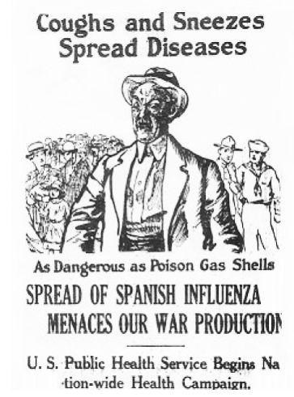The effect of the influenza epidemic was so severe that the average life span in the US was depressed by 10 years. People were struck with illness on the street and died rapid deaths. One anecdote shared of 1918 was of four women playing bridge together late into the night. Overnight, three of the women died from influenza. Others told stories of people on their way to work suddenly developing the flu and dying within hours. One physician writes that patients with seemingly ordinary influenza would rapidly "develop the most viscous type of pneumonia that has ever been seen" and later when cyanosis appeared in the patients, "it is simply a struggle for air until they suffocate.” Another physician recalls that the influenza patients "died struggling to clear their airways of a blood-tinged froth that sometimes gushed from their nose and mouth”. The physicians of the time were helpless against this powerful agent of influenza. In 1918 children would skip rope to the rhyme:

*I had a little bird,*

*Its name was Enza.*

*I opened the window,*

*And in-flu-enza.*

The Great War, with its mass movements of men in armies and aboard ships, probably aided in its rapid diffusion and attack. The origins of the deadly flu disease were unknown but widely speculated upon. Some of the allies thought of the epidemic as a biological warfare tool of the Germans. Many thought it was a result of the trench warfare, the use of mustard gases and the generated "smoke and fumes" of the war.

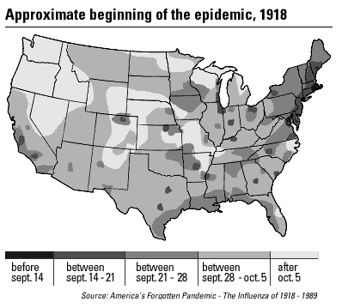A first wave of influenza appeared early in the spring of 1918 in Kansas and in military camps throughout the US. Few noticed the epidemic in the midst of the war. Wilson had just given his 14 point address. There was virtually no response or acknowledgment to the epidemics in March and April in the military camps. It was unfortunate that no steps were taken to prepare for the usual recrudescence of the virulent influenza strain in the winter. The lack of action was later criticized when the epidemic could not be ignored in the winter of 1918. These first epidemics at training camps were a sign of what was coming in greater magnitude in the fall and winter of 1918 to the entire world.

The war brought the virus back into the U.S. for the second wave of the epidemic. It first arrived in Boston in September of 1918 through the port busy with war shipments of machinery and supplies. The war also enabled the virus to spread and diffuse. Men across the nation were mobilizing to join the military and the cause. As they came together, they brought the virus with them and to those they contacted. The virus killed almost 200,00 in October of 1918 alone. In November 11 of 1918 the end of the war enabled resurgence. As people celebrated Armistice Day with parades and large parties, a complete disaster from the public health standpoint, a rebirth of the epidemic occurred in some cities. The flu that winter was beyond imagination as millions were infected and thousands died. Just as the war had affected the course of influenza, influenza affected the war. Entire fleets were ill with the disease and men on the front were too sick to fight. The flu was devastating to both sides, killing more men than their own weapons could.

The pandemic affected everyone. With one-quarter of the US and one-fifth of the world infected with the influenza, it was impossible to escape from the illness. Even President Woodrow Wilson suffered from the flu in early 1919 while negotiating the Treaty of Versailles to end the World War. Those who were lucky enough to avoid infection had to deal with the public health ordinances to restrain the spread of the disease. The public health departments distributed gauze masks to be worn in public. Funerals were limited to 15 minutes. Some towns required a signed certificate to enter and railroads would not accept passengers without them. Those who ignored the flu ordinances had to pay steep fines enforced by extra officers. Bodies pilled up as the massive deaths of the epidemic ensued. Besides the lack of health care workers and medical supplies, there was a shortage of coffins, morticians and gravediggers.

<http://virus.stanford.edu/uda/>